Union Find

Union Find Connected Components Algorithm and the Union Find Data Structure made with linked-lists

# - operations (a.k.a. functions)

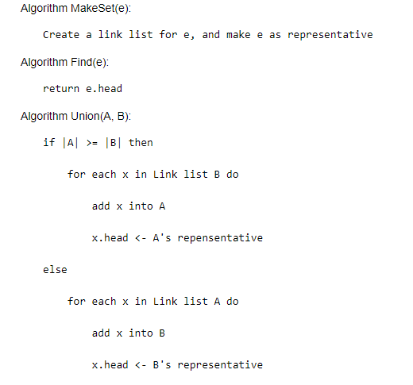

# - runtime analysis for different operations

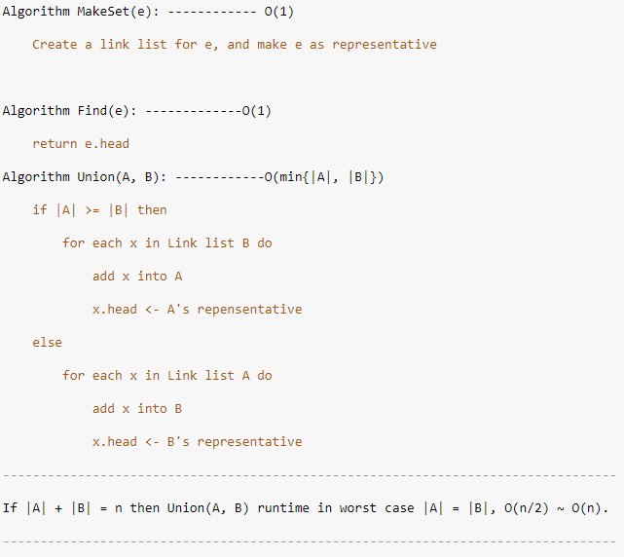

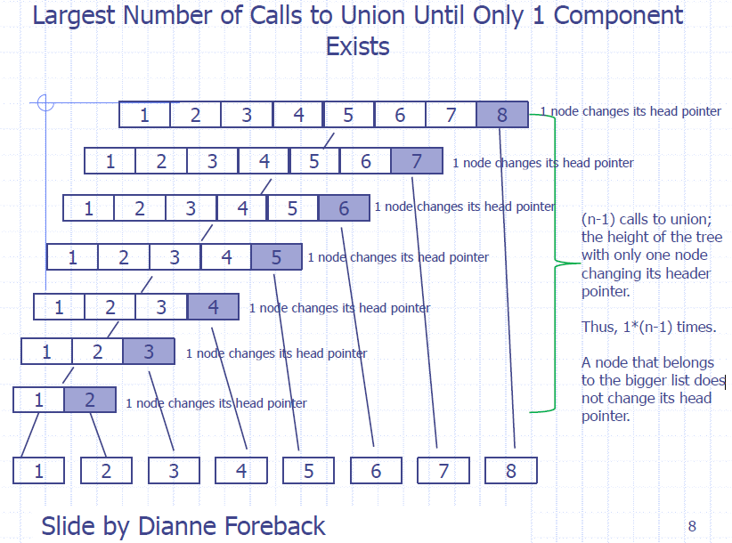

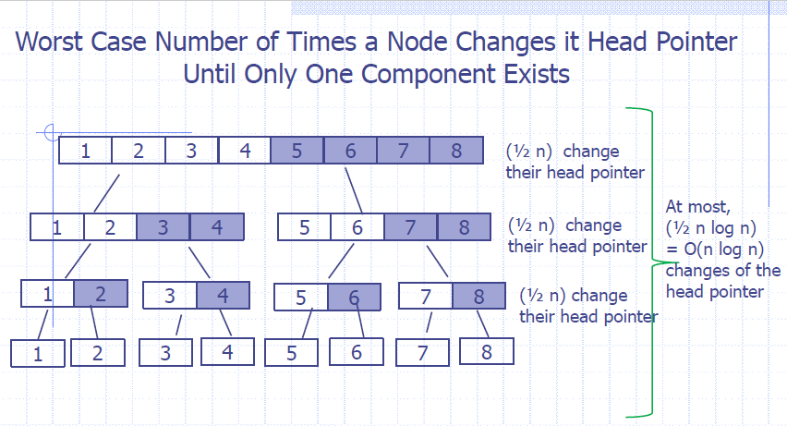

- runtime for creating the data structure

